PRACTICE 5.1. INSTALLING AND RUNNING EXIST DB

STEP 1: eXist db uses port 8080 by default. If you have any program using that port, YOU NEED TO CHANGE IT TO ANOTHER PORT, FOR EXAMPLE 8083. So, first of all, check if port 8080 is LISTENING.

Go to cmd>>netstat –a. Check for port 8080.

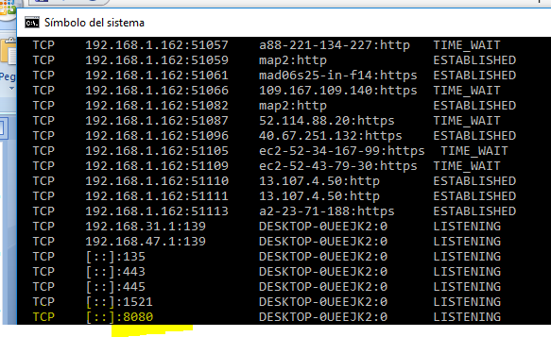

If you see something like that, you will have to change it after the installation and BEFORE YOU RUN EXIST DB FOR THE FIRST TIME. Open the file C:\eXist-db\tools\jetty\etc\jetty-http.xml and change the property “jetty.port” to 8083.

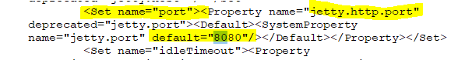

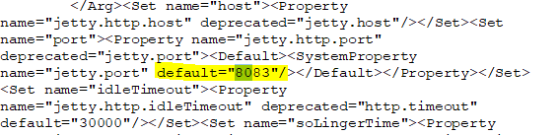

STEP 2: DOWNLOAD eXistdb from <http://exist-db.org/exist/apps/homepage/index.html>

<https://bintray.com/existdb/releases/exist/4.5.0/view>

<https://www.solvetic.com/tutoriales/article/1521-primeros-pasos-con-existdb/>

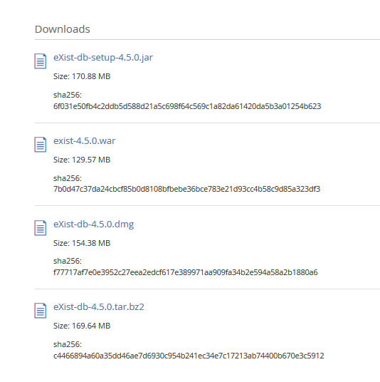

INSTALL THE JAR FILE

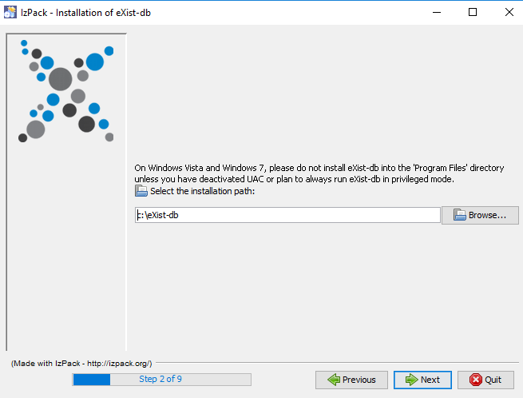 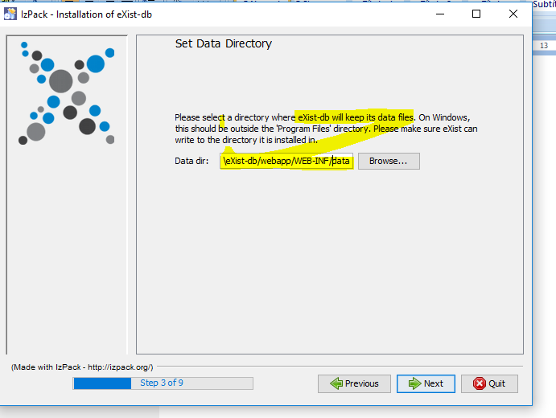

Enter password for user admin: “Patata1234” for example.

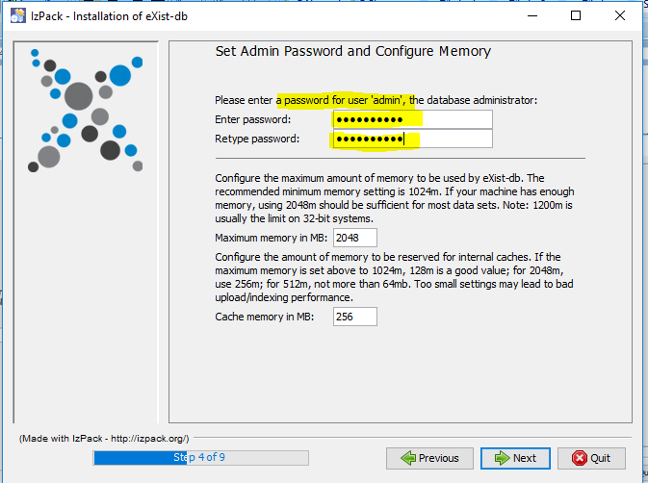 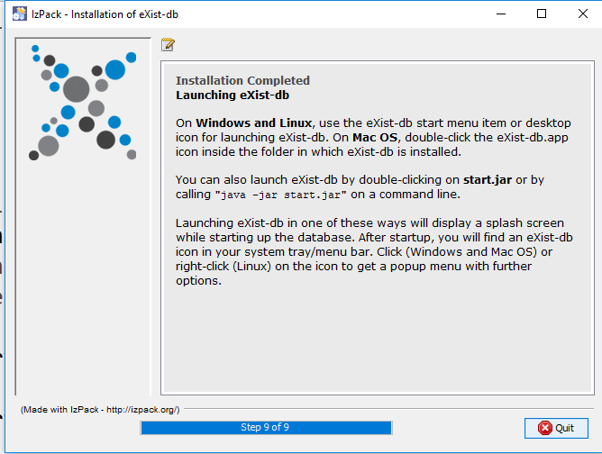

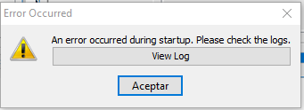 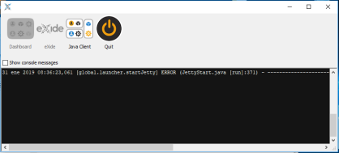

Existis is installed in a web server (jetty) and uses port 8080 by default, as most web servers. If you need to change the port, edit the configuration file C:\eXist-db\tools\jetty\etc. Look for the port “8080” and change it to other value, for example 8083

Cmd: netstat –a:see if port 8080 is busy

STEP3: SWET ENVIRONMET VARIABLES JAVA_HOME , EXIST_HOME

<https://exist-db.org/exist/apps/doc/troubleshooting>

poner el path:

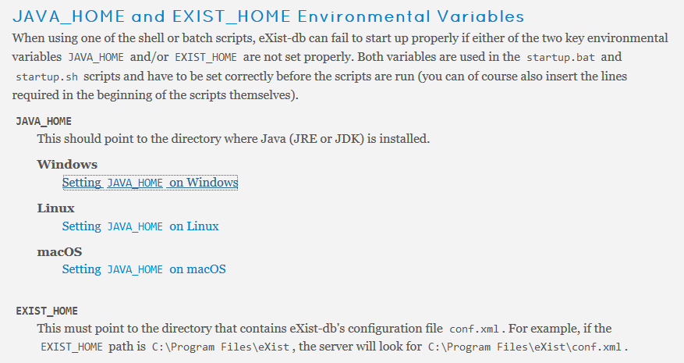

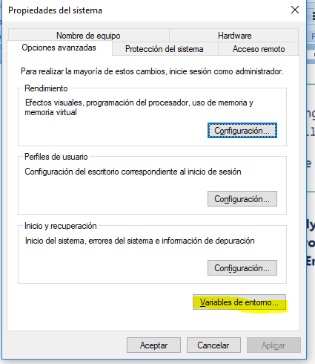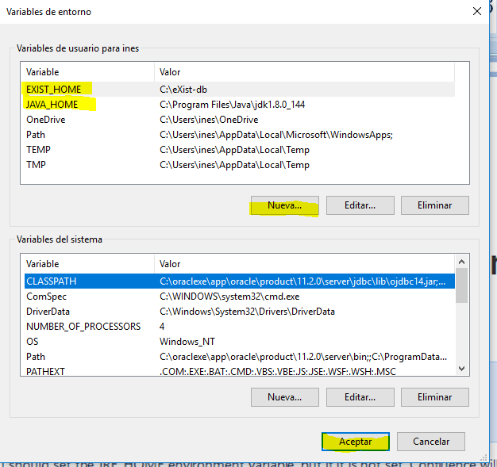

STEP 4 : After installing, you can run Exist clickin on the icon 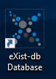

Right click on the icon to see the options. 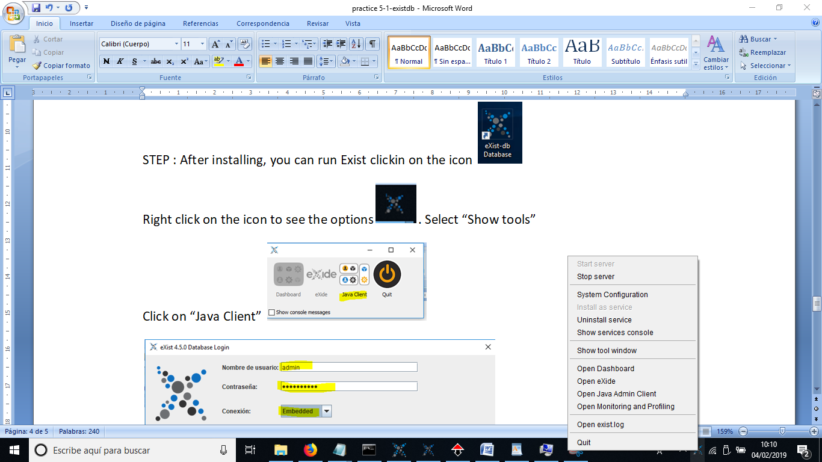

Start the server. Open exist.Log. Check the ip address other relevant information

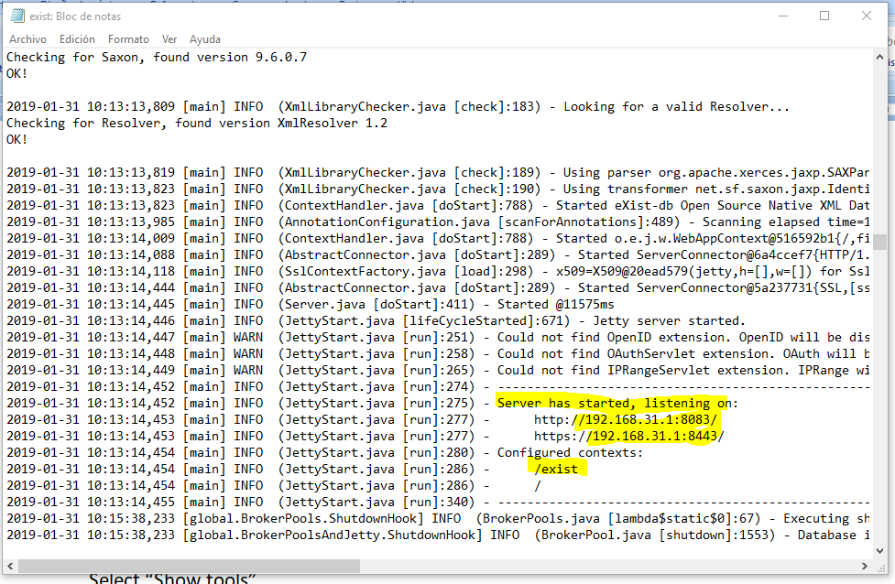

Select “Show tools”

Click on “Java Client” 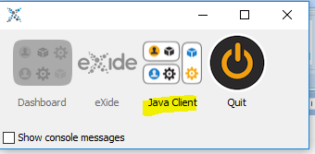

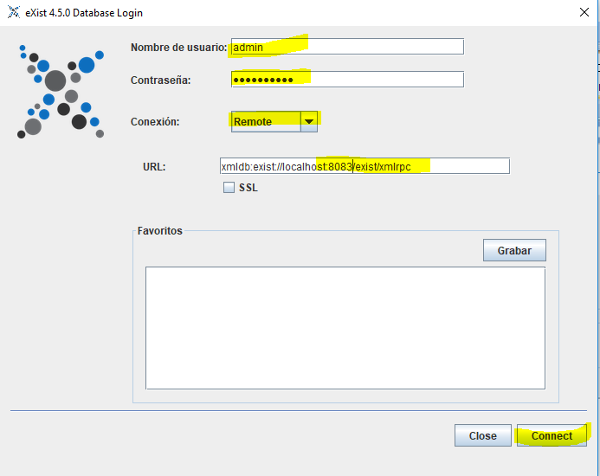

It will open a new window:

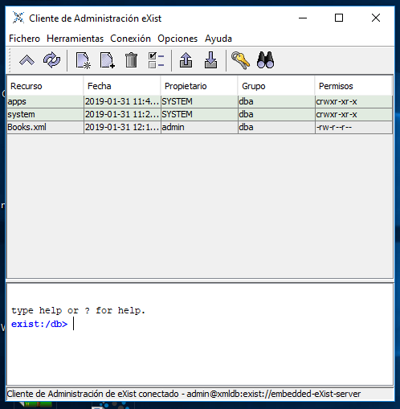

We can create collections (a collection is a directory where we can have documents loaded).

With the option “Fichero>>Almacenar ficheros y directorios”, load xml files to your database: Books.xml and Menu.xml.